

**Yelp Dataset Challenge**

|  |  |
| --- | --- |
| **Team Members:** | * **Ojasvi Maleyvar** * **Ashwin Habbu** * **Darryl Dsouza** * **Shivangi Gupta** |

1. **Design**

In this part, we will detail out the existing landscape of Yelp.com. This would include the graph model of yelp, its attributes and business rules. We will be creating 2 types of pseudo database schemas, MongoDB and Neo4j.

**Mongo DB:**

**Business Rules and Explanation:**

The above graph model represents the amazon review system. It follows the below business  
rules:

1. Nodes represent entities. Following are the selected nodes for the Yelp model,
   1. **Business**

Businesses listed on Yelp.com. These can be restaurants, hotels, gyms, dentists, phone repairs, dry cleaning, massage parlors, etc. Businesses are the blue nodes visible in the model.

* 1. **User**

Customers are individuals registered on Yelp. Users can view all businesses listed on Yelp and post reviews and tips on them. User nodes are highlighted in purple.

* 1. **Review**

Review node represents the reviews posted on Yelp by customers/users. Review nodes are highlighted in green.

* 1. **Tip**

Tips are comments posted by customers/users about businesses. This is not the same as review. It can be treated as extra info posted by users based on experiences. These nodes are highlighted in yellow.

* 1. **CheckIn**

This node denotes the numbers of customers/users who checked into the businesses for each day of the week. Checkin nodes are highlighted in orange.

1. A business can be listed only once on Yelp.
2. A business can have multiple tips, reviews and checkins.
3. Users can post zero or more tips and/or reviews on businesses.
4. Attributes display the fields captured by each node.

**Yelp Database Schema:**

Following are the details of Yelp database schema:

**Database Type:** Document

**Database Name:** Yelp

Schema of each node along with sample data:

1. **Business:**

|  |  |  |  |
| --- | --- | --- | --- |
| **Sr No.** | **Attribute** | **Data Type** | **Sample Values** |
|  | business_id | string | "tnhfDv5Il8EaGSXZGiuQGg" |
|  | name | string | "Garaje" |
|  | neighborhood | string | "SoMa" |
|  | address | string | “475 3rd St” |
|  | city | string | "San Francisco" |
|  | state | string | "CA" |
|  | postal code | string | "94107" |
|  | latitude | float | 37.7817529521 |
|  | longitude | float | -122.39612197 |
|  | stars | float | 4.5 |
|  | review_count | integer | 1198 |
|  | is_open | integer | 1 |
|  | attributes | object | "RestaurantsTakeOut": true,  "BusinessParking": {  "garage": false,  "street": true,  "validated": false,  "lot": false,  "valet": false |
|  | categories | object | "Mexican",  "Burgers",  "Gastropubs" |
|  | hours | object | "Monday": "10:00-21:00",  "Tuesday": "10:00-21:00",  "Friday": "10:00-21:00",  "Wednesday": "10:00-21:00",  "Thursday": "10:00-21:00",  "Sunday": "11:00-18:00",  "Saturday": "10:00-21:00" |

1. **Review:**

|  |  |  |  |
| --- | --- | --- | --- |
| **Sr No.** | **Attribute** | **Data Type** | **Sample Values** |
|  | review_id | string | “zdSx_SD6obEhz9VrW9uAWA” |
|  | user_id | string | "Ha3iJu77CxlrFm-vQRs_8g" |
|  | business_id | string | "tnhfDv5Il8EaGSXZGiuQGg" |
|  | stars | integer | 4 |
|  | date | string | "2016-03-09" |
|  | text | string | “Great place to hang out after work: the……..” |
|  | useful | integer | 0 |
|  | funny | integer | 0 |
|  | cool | integer | 0 |

1. **User:**

|  |  |  |  |
| --- | --- | --- | --- |
| **Sr No.** | **Attribute** | **Data Type** | **Sample Values** |
|  | user_id | string | "Ha3iJu77CxlrFm-vQRs_8g" |
|  | name | string | "Sebastien" |
|  | review_count | integer | 56 |
|  | yelping_since | string | "2011-01-01" |
|  | friends | array of strings | [ "wqoXYLWmpkEH0YvTmHBsJQ",  "KUXLLiJGrjtSsapmxmpvTA",  "6e9rJKQC3n0RSKyHLViL-Q" ] |
|  | useful | integer |  |
|  | funny | integer |  |
|  | cool | integer |  |
|  | fans | integer |  |
|  | elite | array of integers | [ 2012, 2013] |
|  | average_stars | float | 4.31 |
|  | compliment_hot | integer | 32 |
|  | compliment_more | integer | 34 |
|  | compliment_profile | integer | 55 |
|  | compliment_cute | integer | 65 |
|  | compliment_list | integer | 36 |
|  | compliment_note | integer | 77 |
|  | compliment_plain | integer | 32 |
|  | compliment_cool | integer | 22 |
|  | compliment_funny | integer | 11 |
|  | compliment_writer | integer | 44 |
|  | compliment_photos | integer | 67 |

1. **Tip**

|  |  |  |  |
| --- | --- | --- | --- |
| **Sr No.** | **Attribute** | **Data Type** | **Sample Values** |
|  | text | string | "Secret menu - fried chicken…….” |
|  | date | string | "2013-09-20" |
|  | likes | integer | 172 |
|  | business_id | string | "tnhfDv5Il8EaGSXZGiuQGg" |
|  | user_id | string | "49JhAJh8vSQ-vM4Aourl0g" |

1. **Photos**

|  |  |  |  |
| --- | --- | --- | --- |
| **Sr No.** | **Attribute** | **Data Type** | **Sample Values** |
|  | photo_id | string | "_nN_DhLXkfwEkwPNxne9hw" |
|  | business_id | string | "tnhfDv5Il8EaGSXZGiuQGg" |
|  | caption | string | "carne asada fries" |
|  | label | string | "food" |

**Neo4j:**

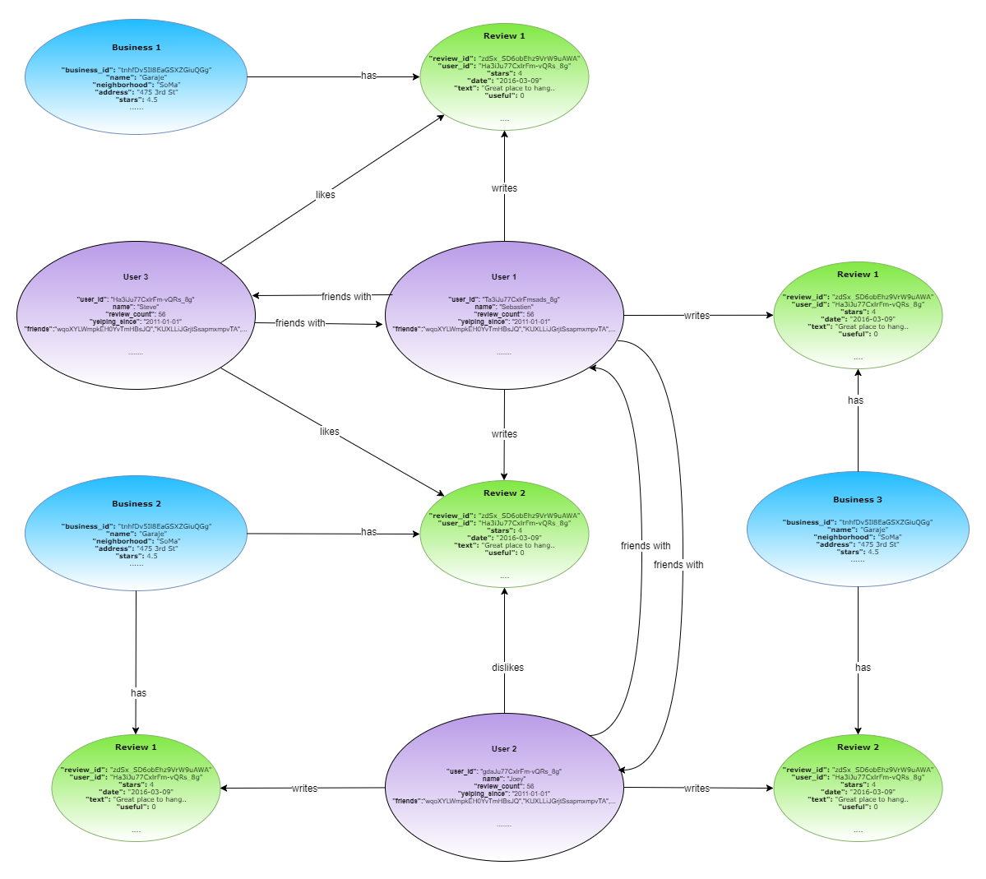

**Business Rules and Explanation:**

The above graph model represents the amazon review system. It follows the below business rules:

1. Nodes represent entities. Following are the selected nodes for the Yelp model,
   1. **Business**

Businesses listed on Yelp.com. These can be restaurants, hotels, gyms, dentists, phone repairs, dry cleaning, massage parlors, etc. Businesses are the blue nodes visible in the model.

* 1. **User**

Customers are individuals registered on Yelp. Users can view all businesses listed on Yelp and post reviews and tips on them. User nodes are highlighted in purple.

* 1. **Review**

Review node represents the reviews posted on Yelp by customers/users. Review nodes are highlighted in green.

1. A business can be listed only once on Yelp.
2. A business can have multiple reviews.
3. Users can post zero or more reviews on businesses.
4. Users can post reviews even if they have not checked into the business.
5. Users may have zero or more friends.
6. Users can like, dislike, comment, rate or complement reviews.
7. Attributes display the fields captured by each node.

**Yelp Database Schema:**

Following are the details of Yelp database schema:

**Database Type:** Document

**Database Name:** Yelp

Schema of each node along with sample data:

1. **Business:**

|  |  |  |  |
| --- | --- | --- | --- |
| **Sr No.** | **Attribute** | **Data Type** | **Sample Values** |
|  | business_id | string | "tnhfDv5Il8EaGSXZGiuQGg" |
|  | name | string | "Garaje" |
|  | neighborhood | string | "SoMa" |
|  | address | string | “475 3rd St” |
|  | city | string | "San Francisco" |
|  | state | string | "CA" |
|  | postal code | string | "94107" |
|  | latitude | float | 37.7817529521 |
|  | longitude | float | -122.39612197 |
|  | stars | float | 4.5 |
|  | review_count | integer | 1198 |
|  | is_open | integer | 1 |
|  | attributes | object | "RestaurantsTakeOut": true,  "BusinessParking": {  "garage": false,  "street": true,  "validated": false,  "lot": false,  "valet": false} |
|  | categories | object | "Mexican",  "Burgers",  "Gastropubs" |
|  | hours | object | "Monday": "10:00-21:00",  "Tuesday": "10:00-21:00",  "Friday": "10:00-21:00",  "Wednesday": "10:00-21:00",  "Thursday": "10:00-21:00",  "Sunday": "11:00-18:00",  "Saturday": "10:00-21:00" |

1. **Review:**

|  |  |  |  |
| --- | --- | --- | --- |
| **Sr No.** | **Attribute** | **Data Type** | **Sample Values** |
|  | review_id | string | “zdSx_SD6obEhz9VrW9uAWA” |
|  | user_id | string | "Ha3iJu77CxlrFm-vQRs_8g" |
|  | business_id | string | "tnhfDv5Il8EaGSXZGiuQGg" |
|  | stars | integer | 4 |
|  | date | string | "2016-03-09" |
|  | text | string | “Great place to hang out after work: the……..” |
|  | useful | integer | 0 |
|  | funny | integer | 0 |
|  | cool | integer | 0 |

1. **User:**

|  |  |  |  |
| --- | --- | --- | --- |
| **Sr No.** | **Attribute** | **Data Type** | **Sample Values** |
|  | user_id | string | "Ha3iJu77CxlrFm-vQRs_8g" |
|  | name | string | "Sebastien" |
|  | review_count | integer | 56 |
|  | yelping_since | string | "2011-01-01" |
|  | friends | array of strings | ["wqoXYLWmpkEH0YvTmHBsJQ",  "KUXLLiJGrjtSsapmxmpvTA",  "6e9rJKQC3n0RSKyHLViL-Q"] |
|  | useful | integer |  |
|  | funny | integer |  |
|  | cool | integer |  |
|  | fans | integer |  |
|  | elite | array of integers | [ 2012,  2013] |
|  | average_stars | float | 4.31 |
|  | compliment_hot | integer | 32 |
|  | compliment_more | integer | 34 |
|  | compliment_profile | integer | 55 |
|  | compliment_cute | integer | 65 |
|  | compliment_list | integer | 36 |
|  | compliment_note | integer | 77 |
|  | compliment_plain | integer | 32 |
|  | compliment_cool | integer | 22 |
|  | compliment_funny | integer | 11 |
|  | compliment_writer | integer | 44 |
|  | compliment_photos | integer | 67 |

For analysis purpose, we have created the following collections,

1. **Business_subset:** All businesses from the city ‘Tempe’ & ‘Chandler’

*db.business.aggregate([{$lookup:{from:"review",localField:"business_id",foreignField:"business_id",as:"bus_reviews"}},{$unwind:"$bus_reviews"},{$project:{"_id":"$bus_reviews.id","review_id":"$bus_reviews.review_id","user_id":"$bus_reviews.user_id","business_id":"$bus_reviews.business_id","text":"$bus_reviews.text","useful":"$bus_reviews.useful","stars":"$bus_reviews.stars","date":"$bus_reviews.date","funny":"$bus_reviews.funny", "cool":"$bus_reviews.cool"}},{ $out: "business_subset_review" }])*

1. **Review_subset:** All reviews for the businesses in the two cities

*db.business.aggregate([{$lookup:{from:"review",localField:"business_id",foreignField:"business_id",as:"bus_reviews"}},{$unwind:"$bus_reviews"},{$project:{"_id":"$bus_reviews.id","review_id":"$bus_reviews.review_id","user_id":"$bus_reviews.user_id","business_id":"$bus_reviews.business_id","text":"$bus_reviews.text","useful":"$bus_reviews.useful","stars":"$bus_reviews.stars","date":"$bus_reviews.date","funny":"$bus_reviews.funny", "cool":"$bus_reviews.cool"}},{ $out: "review_subset" }])*

1. **User_subset:**

*db.user.aggregate([([{$lookup:{from:"review_subset",localField:"user_id",foreignField:"user_id",as:"usersubset"}},{$unwind:"$usersubset"},{$project:{"_id":"$usersubset.user_id","name":"$name","review_count":"$review_count","yelping_since":"$yelping_since","friends":"$friends","elite":"$elite"}},{$out:"user_subset"}]])*

1. **Checkin_subset:**

*db.checkin.aggregate([{$lookup:{from:"business",localField:"business_id",foreignField:"business_id",as:"checkinsubset"}},{$unwind:"$checkinsubset"},{$project:{"_id":"$checkinsubset.business_id","time":"$checkinsubset.time"}},{$out:"checkin_subset"}])*

db.review.createIndex({review_id:1},{unique:1})

db.review.createIndex({business_id:1})

db.checkin.createIndex({business_id:1})

db.tip.createIndex({business_id:1})

db.tip.createIndex({user_id:1})

db.business.createIndex({business_id:1},{unique:1})

1. **Basic Understanding of the Data (Queries and insights)**

The below section describes several queries which were used to describe the dataset. List of screenshots and results can be found below.

1. **Overall Number of Businesses**

*db.business_subset.find().count()*

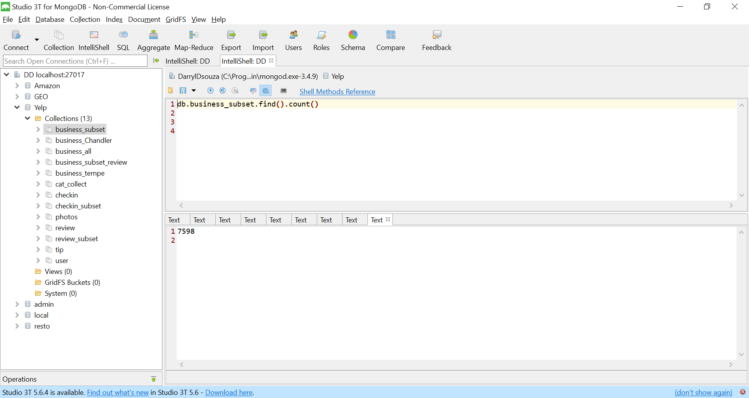

**Explanation:** We have created a new subset of businesses which consists of all business from two cities, ‘Chandler’ and ‘Tempe’. The above query returns the count of businesses from these two cities.

**Result:** 7598

1. **Overall number of reviews:**

*db.review_subset.find().count()*

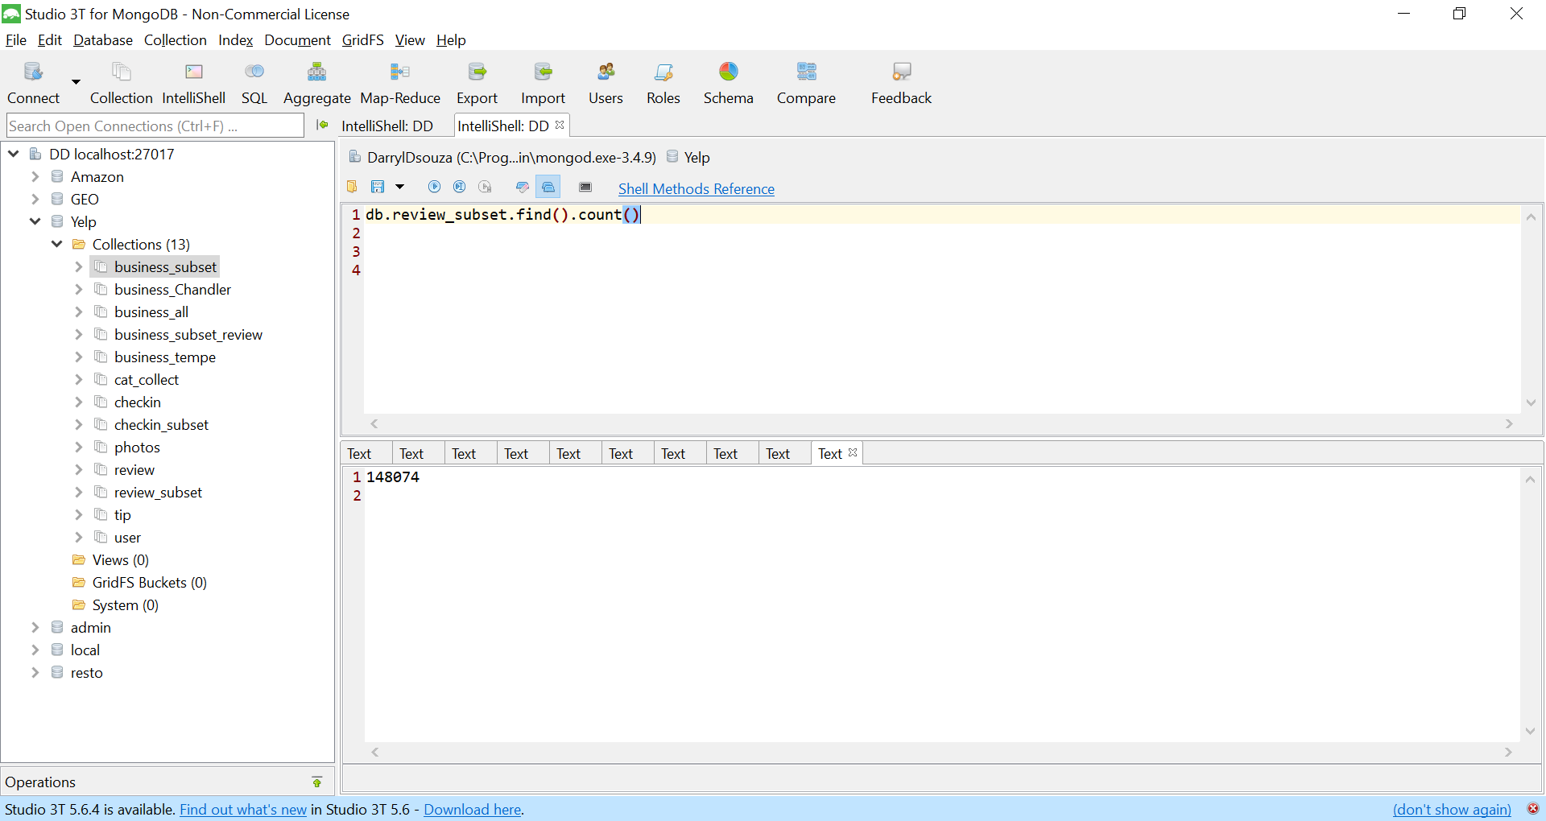

**Explanation:** Similar to the business subset, we have created a review subset consisting of reviews of all businesses from two cities ‘Chandler’ and ‘Tempe’. The above query displays the count of reviews across all businesses located in these two cities.

**Result:** 148074

1. **Overall number of reviewers:** *db.review_subset.aggregate([{$group:{_id:"$user_id"}},{$count:"Numberofreviewers"}])*

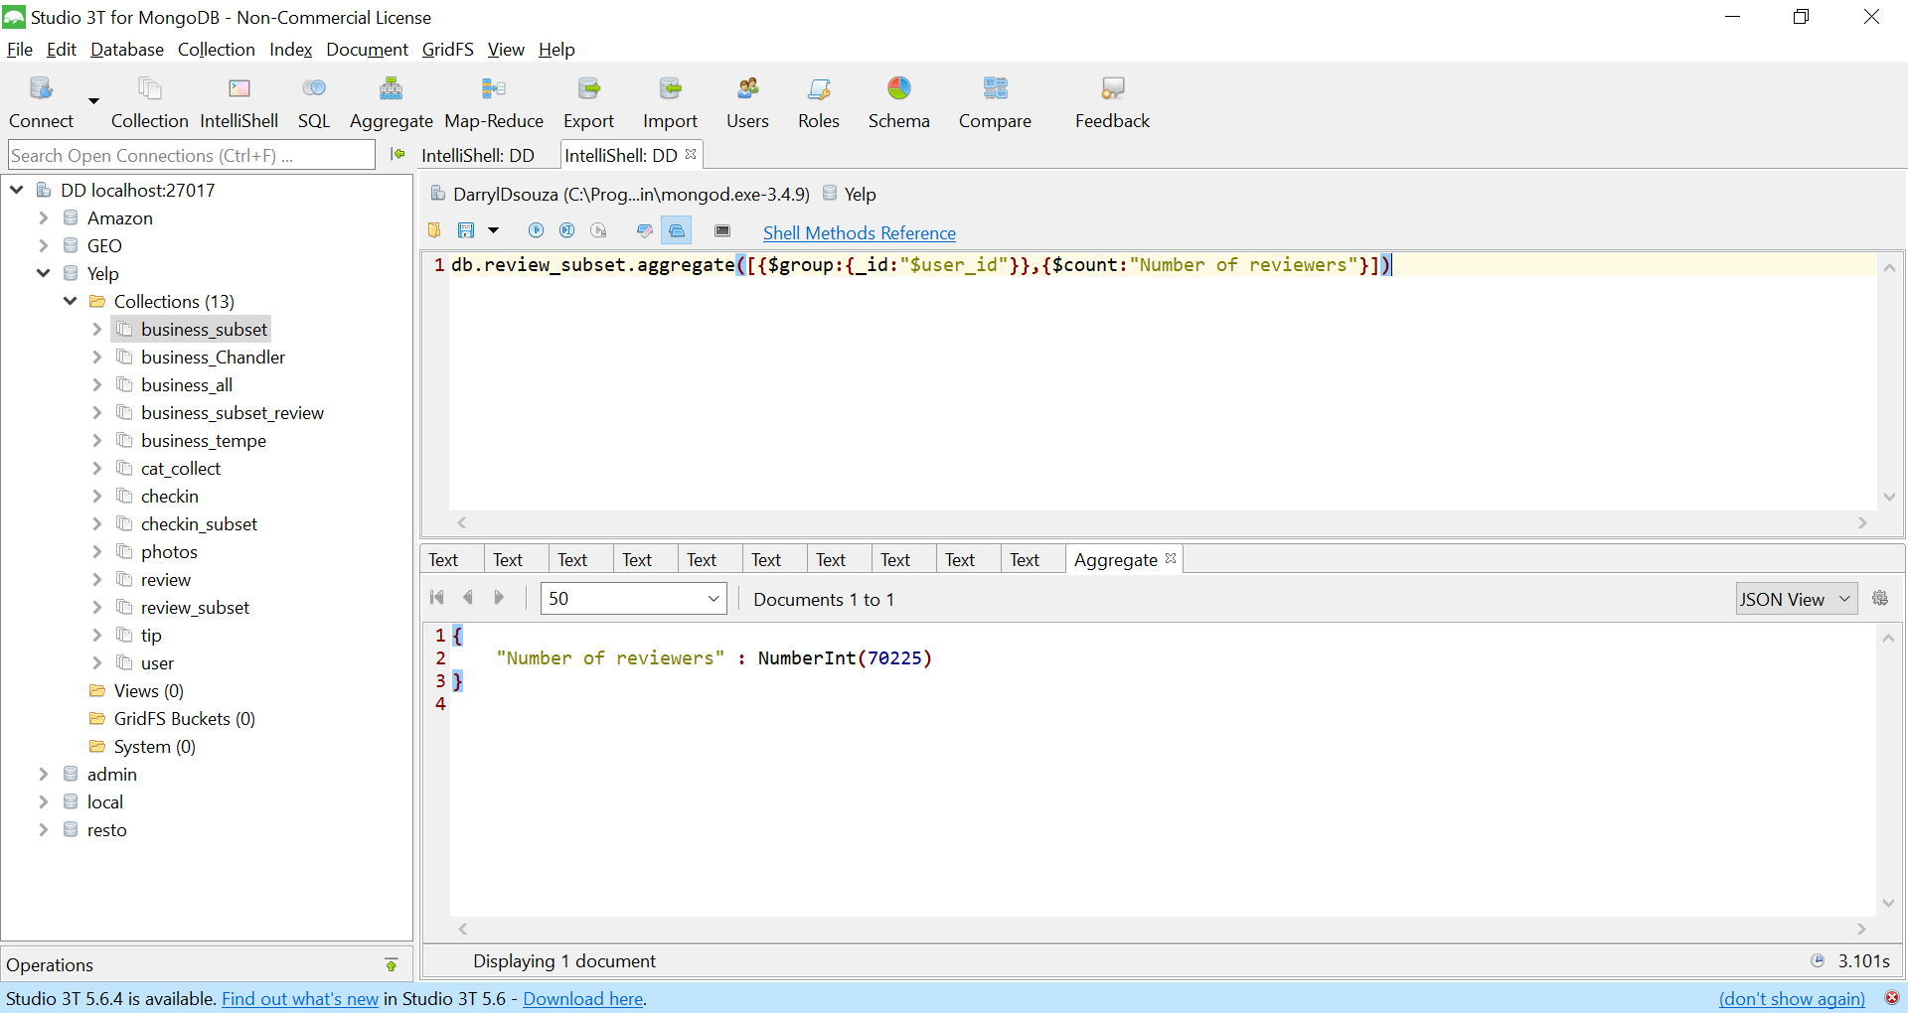

**Explanation:** The above query displays the count of reviewers. To fetch the output, user_id has been grouped together and their count has been displayed.

**Result:** 70225

1. **Overall count of reviews less than 3 rating:** db.review_subset.aggregate([{$match:{stars:{$lt:3}}},{$count:"No of reviews"}])

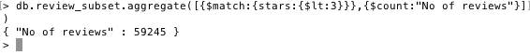

**Explanation:** The query displays all reviews from ‘Chandler’ and ‘Tempe’, with rating below 3. This is achieved by matching records with ‘stars’ less than value ‘3’.

**Resut:** 59245

1. **Overall count of reviews greater than ratings 3:** db.review_subset.aggregate([{$match:{stars:{$gt:3}}},{$count:"No of reviews"}])

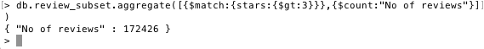

**Explanation:** The query displays all reviews from ‘Chandler’ and ‘Tempe’, with rating greater than 3. This is achieved by matching records with ‘stars’ greater than value ‘3’.

**Result:** 172426

1. **Average number of reviews per business**

db.review_subset.aggregate([{$group:{_id:"$business_id",average_review:{$avg:"$stars"}}}])

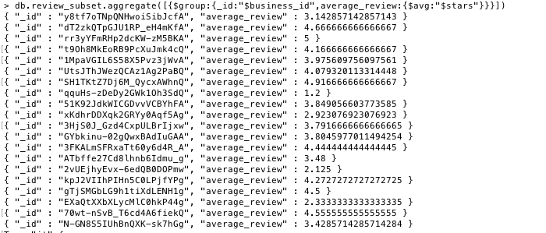

**Explanation:** The query displays average review rating per business. This is achieved by using average function.

1. **Top 10 prolific reviewers:**

db.review_subset.aggregate([{$group:{_id:{Reviewer_id:"$user_id"},reviewcount:{$sum:1}}},{$sort:{'reviewcount':-1}},{$limit:10}])

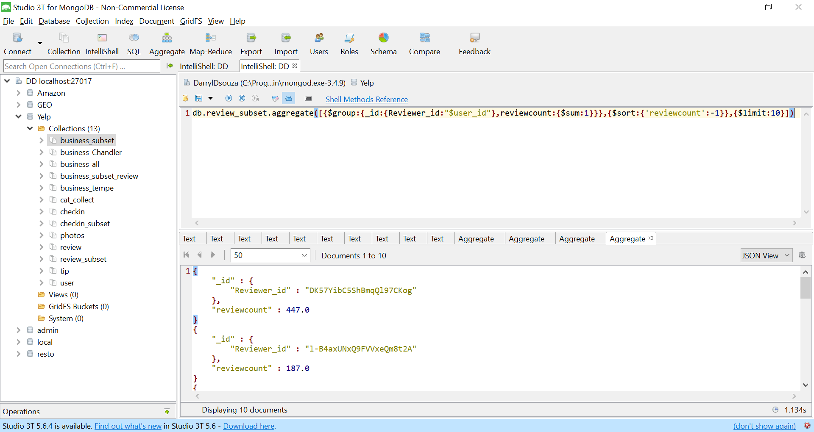

**Explanation:** This query returns the top 10 reviewers with the most number of reviews. This is achieved by fetching the count of reviews, sorting it in descending order and limiting rows to 10 records.

1. **Business Categories:**

db.business_subset.aggregate([{$group:{_id:"$business_id",catList:{$push:"$categories"}}},{$unwind:"$catList"},{$unwind:"$catList"},{$group:{_id:"$catList",business:{$push:"$_id"}}},{$out:"Categories_with_businesses"}])

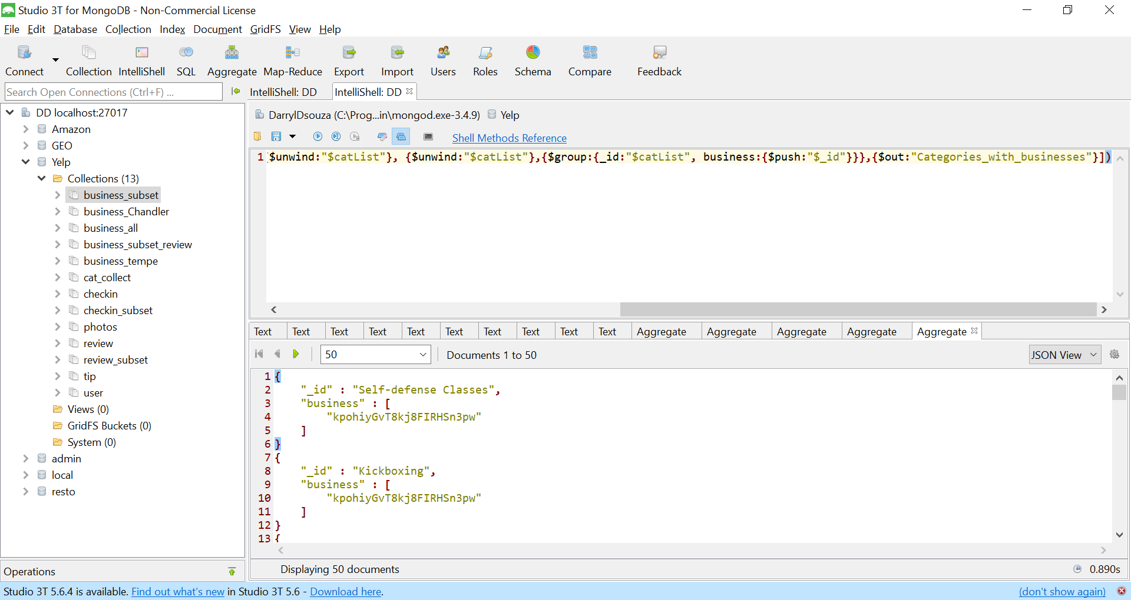

**Explanation:** The above query returns the list of all businesses and its categories. This is achieved by unwinding the category list collection and grouping category with business id.

1. **Top 10 verbose reviewers:**

*db.review_subset.aggregate([{$project:{"reviewerID":"$user_id","count":{$strLenCP:"$text"}}},{$sort:{count:-1}},{$limit:10}])*

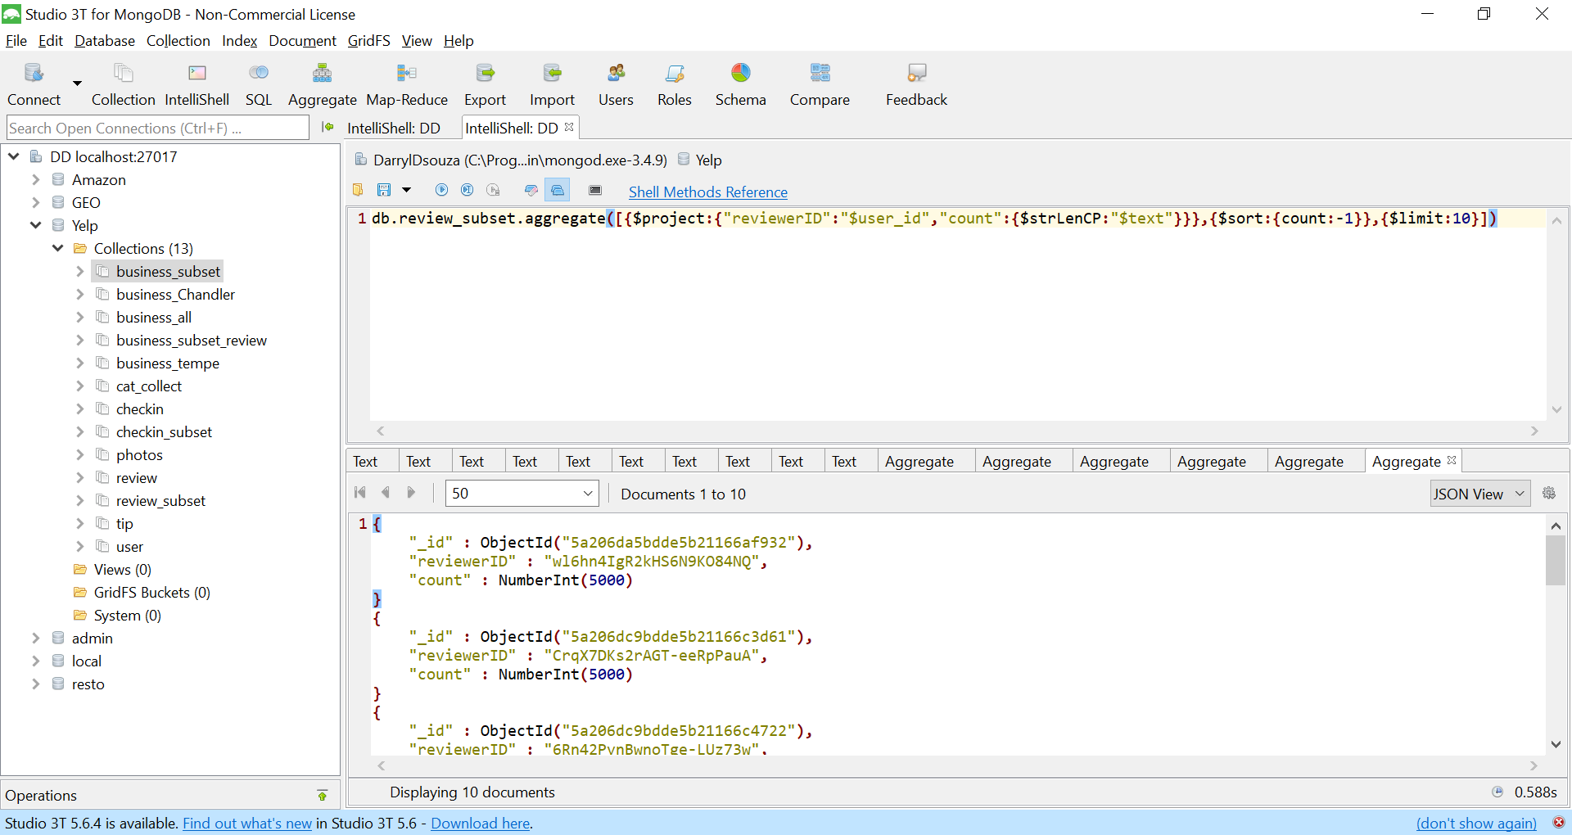

**Explanation:** The above query returns top 10 verbose reviews. This is achieved by getting the most number of letters in the review.

1. **Report and interpret your findings (e.g., if you find that there are more positive (>3) reviews than negative (<3), what implication does that have? Is the trend the same across businesses types? What about restaurants?)**

*db.review_count.aggregate([{$project:{_id:0,"Business_id":"$Business_id","postive_count":"$positive_count","negative_count":"$negative_count",total_count:{$add:["$positive_count","$negative_count"]},positive_percentage:{$divide:["$positive_count",{$add:["$positive_count","$negative_count"]}]}}},{$sort:{positive_percentage:-1}},{$limit:10}])*

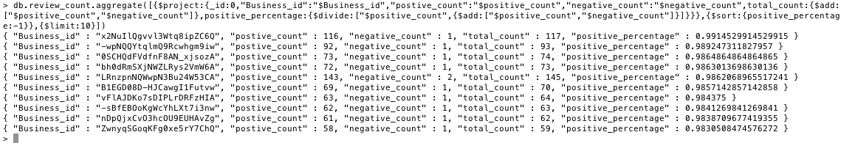

**Explanation:** The above query returns top 10 business with most positive percentage (reviews).  
First we divided our review subset in two categories (i) Top Business: business with reviews greater than 3, (ii) Bottom Business: business with reviews less than 3.

Second, we grouped both top business & bottom business dataset into one dataset (review_count) which has positive count of number of reviews (top business count) and negative count of number of reviews (bottom business count) per business.

Third, we calculated positive percentage of a business i.e (positive count +negative count)/positive count)

1. **Analytics**

**Following are the five metrics derived from MongoDB using the Yelp dataset.**

**1. Top 10 reviewers in a particular zipcode**

The above metric can determine top reviewers based on their number of reviews

in particular neighborhood. This metric can be used by a customer to check who are the top reviewers in his location.



The above graph shows the result for zip code [85281]. In this case we have “Karen” who has the

highest number of reviews in this location. The results are generated with the help of below mongo dB query.

db.review_business.aggregate([{$match:{postalcode:"85281"}},{$group:{_id:{"User":"$user_id","zip":"$postalcode"},reviewer_count:{$sum:1}}},{$sort:{reviewer_count:-1}},{$limit:10}])

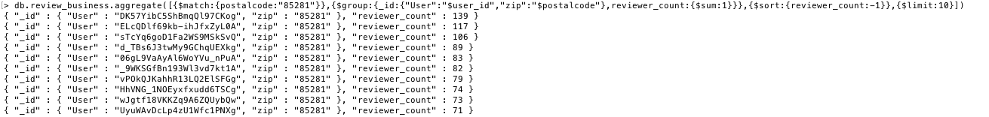

**Explanation:** The above query returns list of top 10 reviewers in a particular zipcode. This is achieved by first creating a collection review_business which has zipcode, review_id, business_id.

**Problem:** Is Karen a good reviewer?

**Solution:** One of the solution for this problem is figured out by finding Karen is a Yelp Elite Squad since 2013.

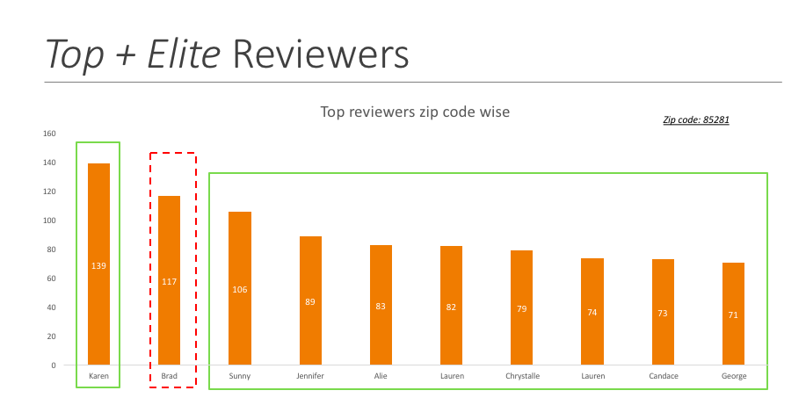

In this case: Karen is an Elite user, but Brad is not.

**2.Elite users per year**

What Makes a Great Yelp Elite Squad Member?

* Awesome reviews
* Great photos
* Sending others compliments

The above metric helps the business to calculate number of elite users per year.



db.user_subset.aggregate([{$unwind:"$elite"},{$group:{_id:"$elite",count:{$sum:1}}},{$sort:{"count":1}}])

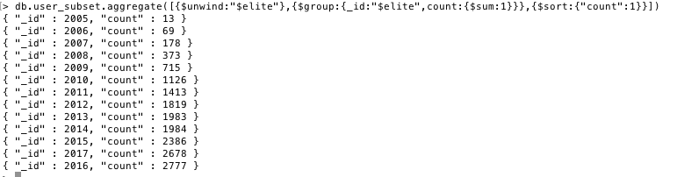

**Explanation:** The above query returns number of elite users per year.

**3.Top 10 businesses in a particular zipcode**

The above metric can determine top businesses based on their rating in particular neighborhood. This metric can be used by a customer to check who are the top businesses in his location. Also, this metric can be used by Yelp to figure out category wise which are top rated businesses.

Below is Mongo Db query for this metric:

db.business.aggregate([{$match:{postal_code:"85281"}},{$group:{_id:{"BusinessID":"$business_id","zip":"$postal_code"},stars:{$push:"$stars"},name:{$push:"$name"}}},{$sort:{stars:-1}}])

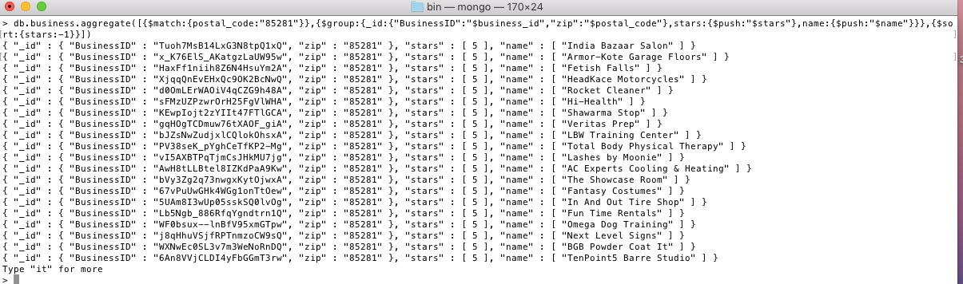

**Explanation:** The above query returns the list of all businesses and its categories. This is achieved by unwinding the category list collection and grouping category with business id.

Analysis:

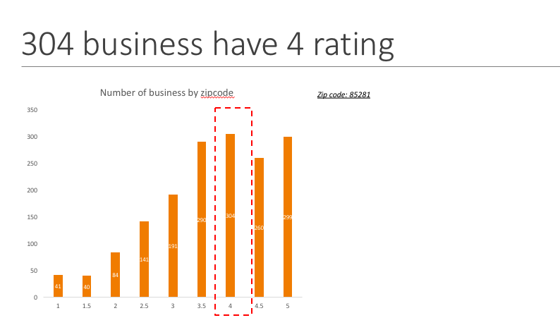

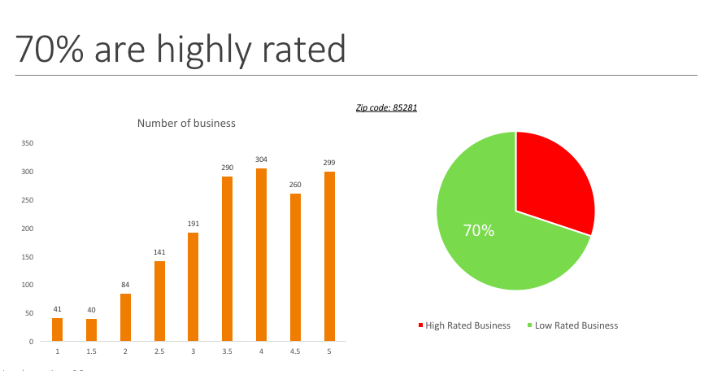

**4.Top 10 most recent reviews**

*db.review_subset.find({},{review_id:1,date:1}).sort({date:-1}).limit(10)*

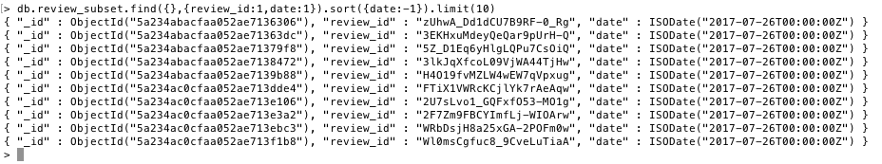

**Explanation:** The above query returns top 10 most recent reviews. To obtain the results we have sorted the review collection with date.

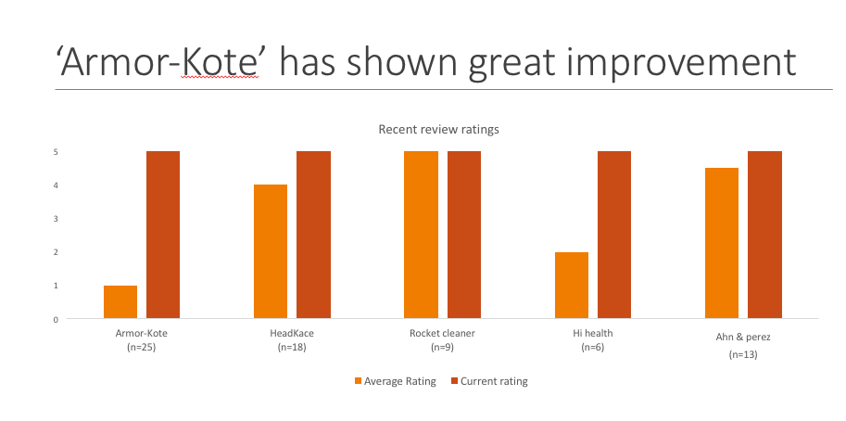

**5.Year on Year analysis**

db.review_subset.aggregate([{$sort:{date:-1}},{$group:{_id:{"business_id":"$business_id","year":{$year:"$date"}},average_review:{$avg:"$stars"}}},{$sort:{business_id:1,year:-1}},{$group:{_id:"$_id.business_id",yoy_data:{$push:{year:"$_id.year",average_review:"$average_review"}}}}])



**Explanation:** The above query returns the list of all businesses and its categories. This is achieved by unwinding the category list collection and grouping category with business id.

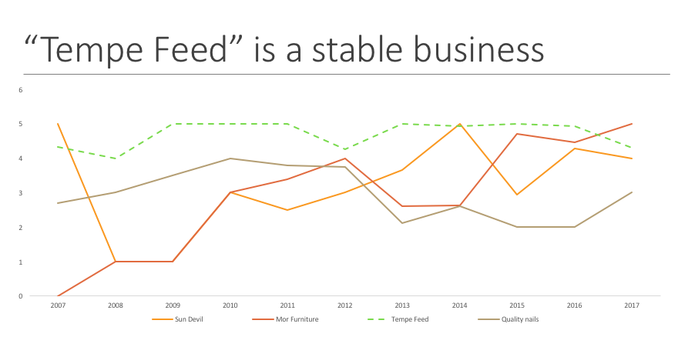

**For Example in this case we can use this metric to present which is a stable business**

1. **Helpfulness of Reviews (MongoDB Analysis)**

For a text-based definition of ‘helpfulness’ of reviews, we have created a corpus of words we considered useful, to determine the helpfulness of a review. The keywords contain both neutral, positive, negative, descriptive words and adjectives. The corpus consists of the following words:

We sort the reviews according to their text-based meta scores in descending order to obtain the most helpful review. The highest meta score returned is approximately 11.266 for the most helpful review based on our text-based definition. For further analysis, we created a new collection of the obtained result called “textbased_helpful_reviews”. We will use this to make a comparison with the helpful reviews obtained from a non-text based definition.

**Creating an index on the field “text” (Text of review):**

*db.review_subset.createIndex({text:"text"})*

**Query for text-based helpful reviews:**

*db.review_subset.aggregate([{$match:{$text:{$search:" better extremely right quality experience quick friendly adept suggest good useful best awesome super cool supercool lovely amazing great excellent nice glad love adore disappointed pathetic sad bad perfect wonderful variety staff help fresh delicious terrible horrific rude awful fantastic ambience"}}},{$sort:{score:{$meta:"textScore"}}},{$project:{reviewID:"$review_id", score: { $meta: "textScore" },_id:0}},{$out:"textbased_helpful_reviews"}])*

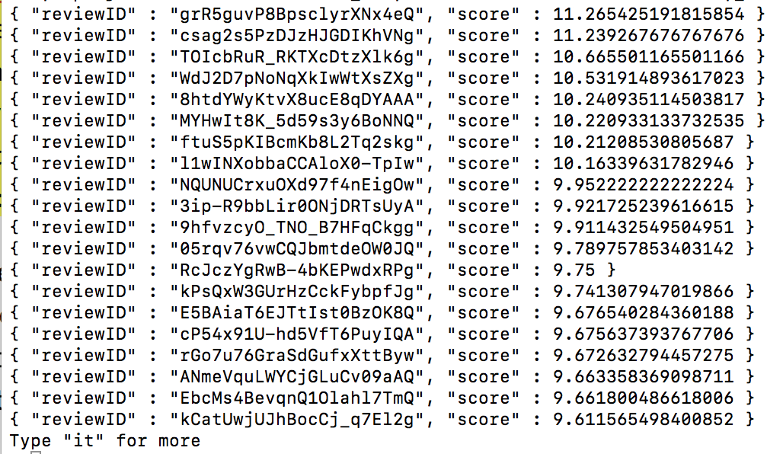

We create a non-text based definition which accounts for the total number of ‘useful’, ‘funny’, ‘cool’ which are numerical values. The ‘helpfulness’ is defined as the total number of useful, cool and funny comments a review has received. We also use an additional filter where we discard the reviews which have received extreme ratings (1 star & 5 star rated reviews) as ‘perfectly good’ and ‘perfectly bad’ reviews have little bearing on the actual ‘helpfulness’ since experiences of different users are subjective and depend on various personal user preferences and moods. As a result, our most helpful review in this case has a Total Score of 229.

**Query for non-text based helpful reviews:**

*db.review_subset.aggregate([{$match:{stars:{$gt:1,$lt:5}}},{$project:{_id:0, review_id:1, totalScore:{$add:["$useful","$funny","$cool"]}}},{$sort:{totalScore:-1}},{$out:"nontextbased_helpful_reviews"}])*

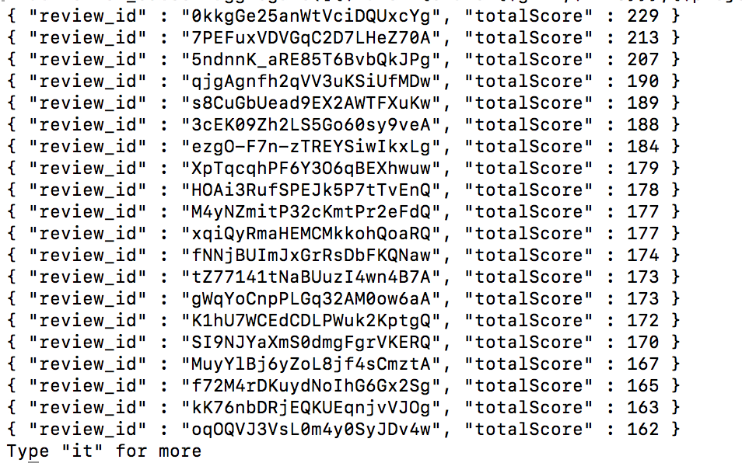

**Text Based Vs. Non-Text Based comparison**

Here we compare the two approaches to verify helpfulness of the reviews. For the same purpose, we have exported our two previously created collections to CSV files.

*./mongoexport --db Yelp --collection nontextbased_helpful_reviews --type=csv –out /Users/oj/Yelp/ nontextbased_helpful_reviews.csv --fields reviewID, score*

*./mongoexport --db Yelp --collection textbased_helpful_reviews --type=csv --out /Users/ oj /Yelp/ textbased_helpful_reviews.csv --fields review_id, totalScore*

We open these files in excel and perform a VLOOKUP to find out how many reviews exist in both datasets. Our findings show that we have 93816 matched records between 100960 Non-text based helpful review and 239728 Text-based helpful reviews. This gives us approximately 93% accuracy between the two approaches.

1. **Neo4j Analytics**

**Importing data into Neo4j**

Importing the business subset:load csv with headers from "file:///business_subset.csv" as business

create (:business {business_id: business.business_id,name:business.name,city:business.city,postalcode:business.postal_code})

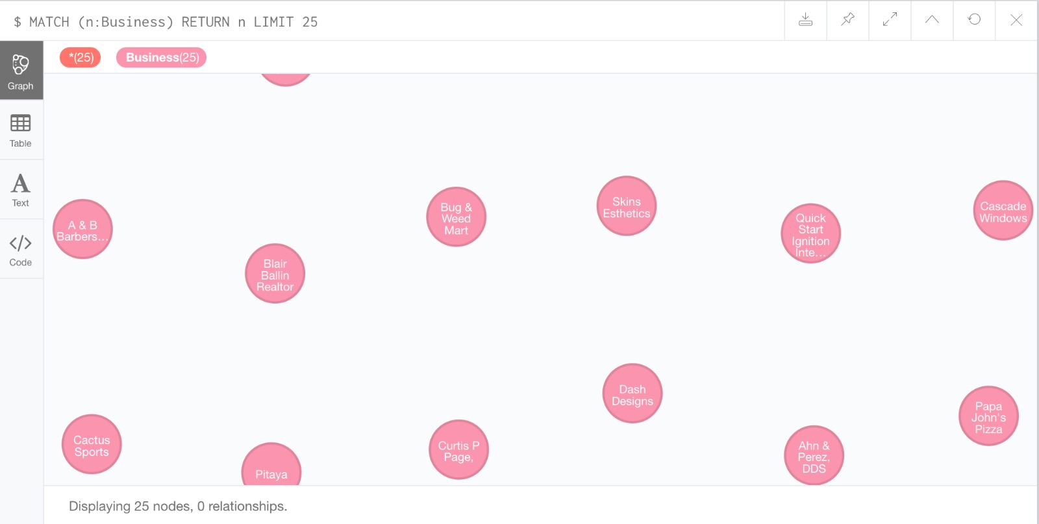

Importing the review subset:

load csv with headers from "file:///review_subset.csv" as review

create(r:review{review_id:review.review_id,business_id:review.business_id,user_id:review.user_id,stars:review.stars})

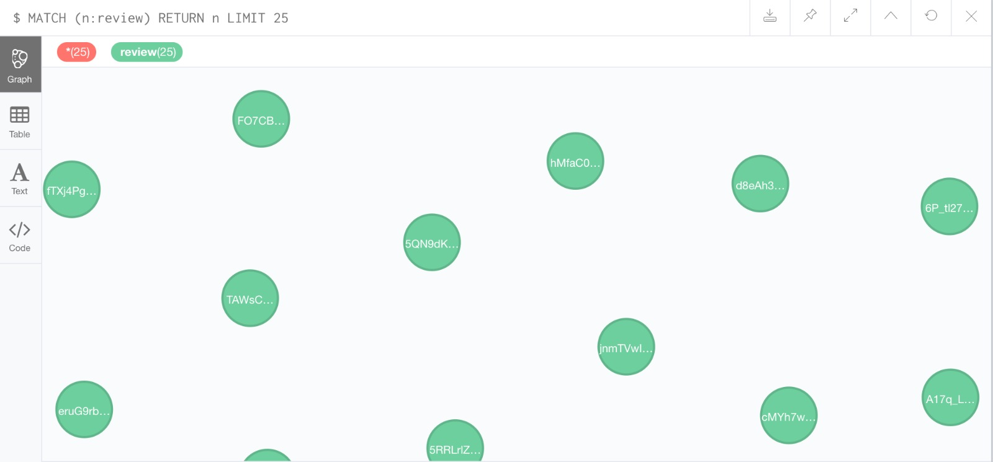

Importing the user subset:

load csv with headers from "file:///user_subset.csv" as user

create (u:user{user_id:user.user_id, name:user.name})

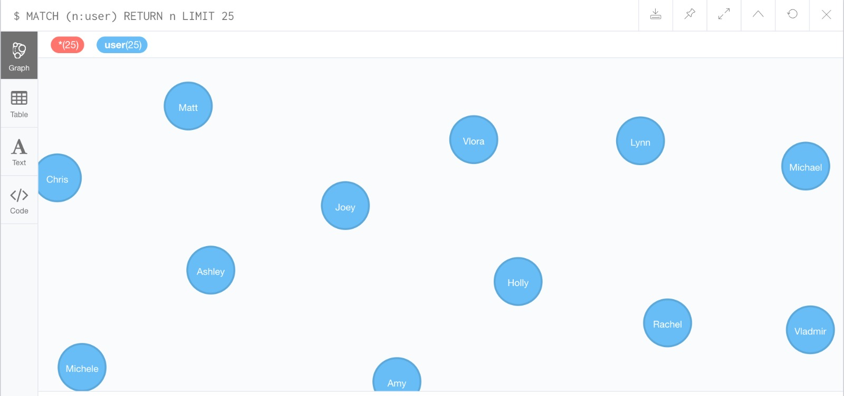

Creating Relations between the nodes:  
MATCH (u:user), (r:review) WHERE u.user_id = r.user_id CREATE (u)-[p:wrote]->(r)

RETURN p  
  
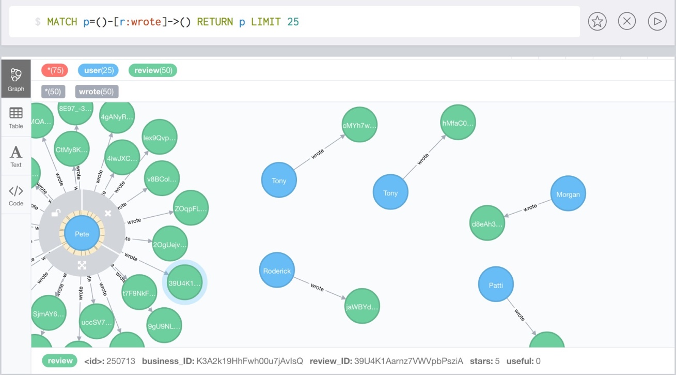

MATCH (b:Business), (r:review) WHERE b.business_ID = r. business_ID CREATE (b)-[h:has_reviews]->(r) RETURN b, r

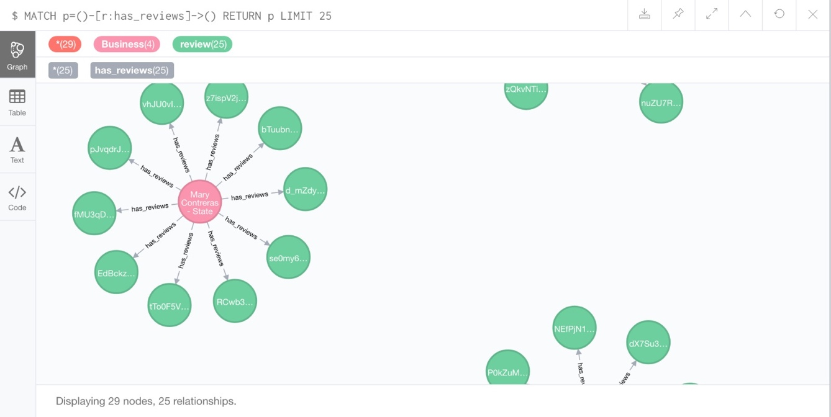

**Determine ‘mob’ behavior on Yelp reviews section:**

match (r:review),(u:user)

where r.user_id=u.user_id

with distinct r.business_ID as business, u as user

return user.name as Reviewer_Name, business, count(user) as user_count

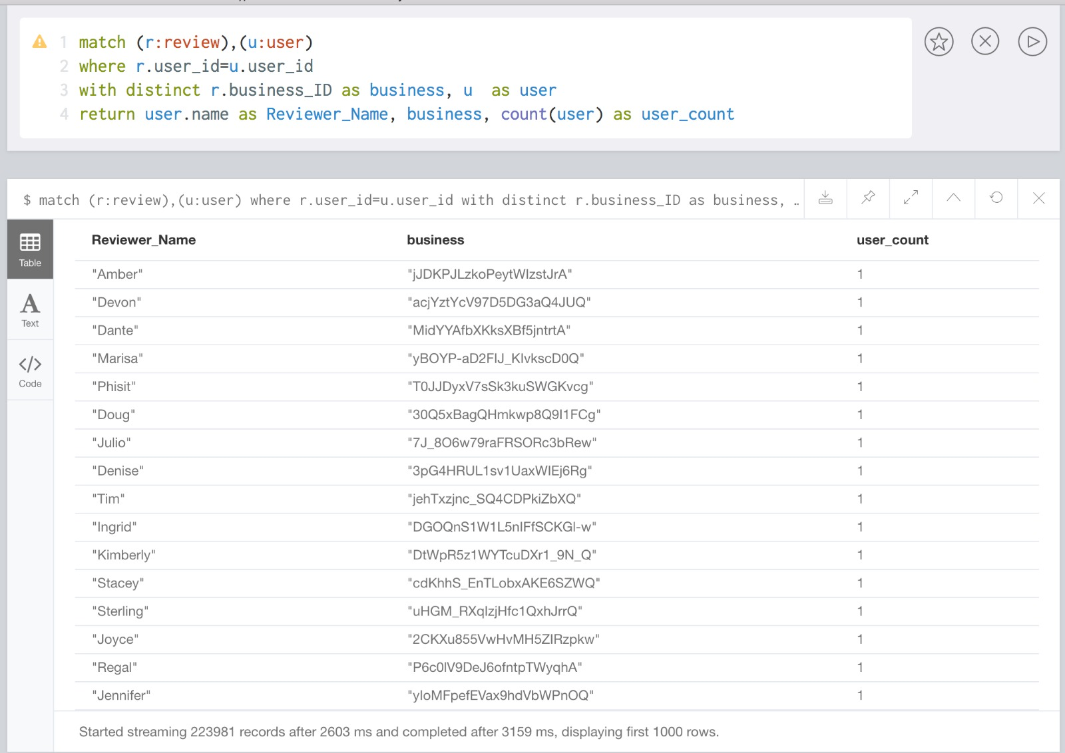

This query gives us a view of the number of times a user has reviewed a business. We are doing this to find out any mob behavior which may be occurring on Yelp’s website. We notice in the results that any user gives only one review to a business. This confirms the fact that Yelp does not allow mob behavior by limiting the number of reviews per business per user to one only.

**To determine if geographical proximity leads to uniformity in business ratings or divergence:**

match (b:Business)-[:has_reviews]-(r:review)

return b.city as City, b.zipcode as Zipcode, stdev(toint(r.stars)) as Standard_deviation

order by Standard_deviation desc

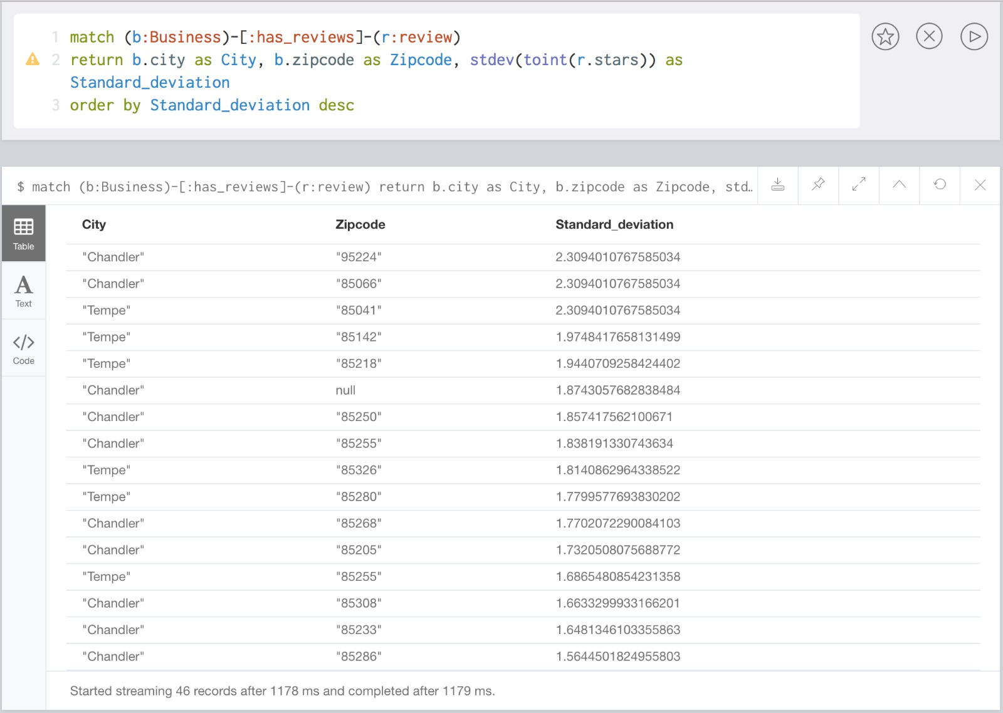

match (b:Business)-[:has_reviews]-(r:review)

return b.city as City, stdev(toint(r.stars)) as Standard_deviation

order by Standard_deviation desc

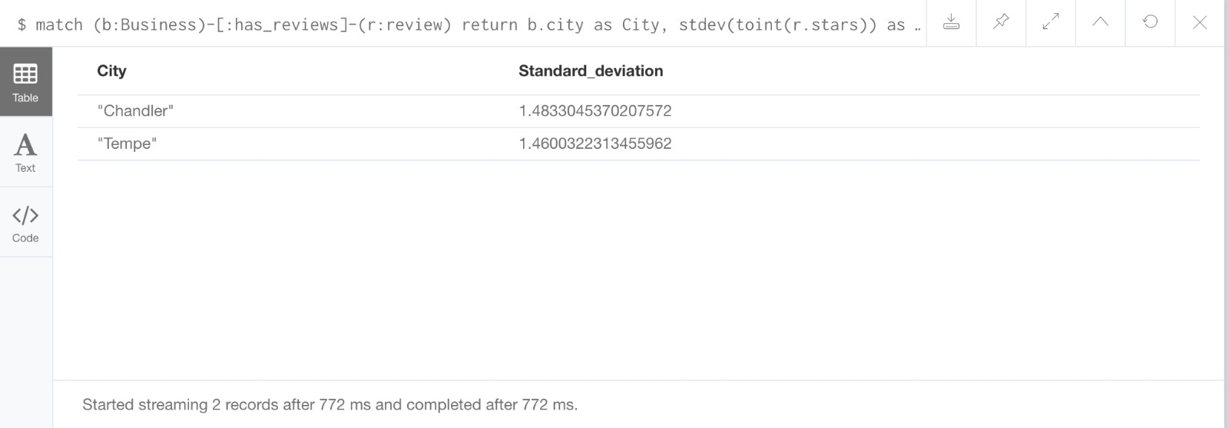

match (biz:business) with point({longitude: biz.longitude, latitude: biz.latitude}) as bpoint,biz match (biz2:business) with point({longitude: biz2.longitude, latitude: biz2.latitude}) as bpoint2, biz2, biz, bpoint with round(distance(bpoint, bpoint2)) as dist, biz, biz2, bpoint, bpoint2 where dist<10 with biz.id as bid, b2.city as city, collect(biz2.id) as nearbybiz, avg(biz2.stars) as avgstars,stdev(biz2.stars) as stddev, count(biz2) as conb with city, collect(bid) as bid, nearbybiz as nearbybiz, round(100*avgstars)/100 as avgstars, round(100*stddev)/100 as stddev, countbiz as countbiz where countbiz > 1 return city as city_name, avg(stddev) as average_sd, avg(avgstars) as average_mean_rating

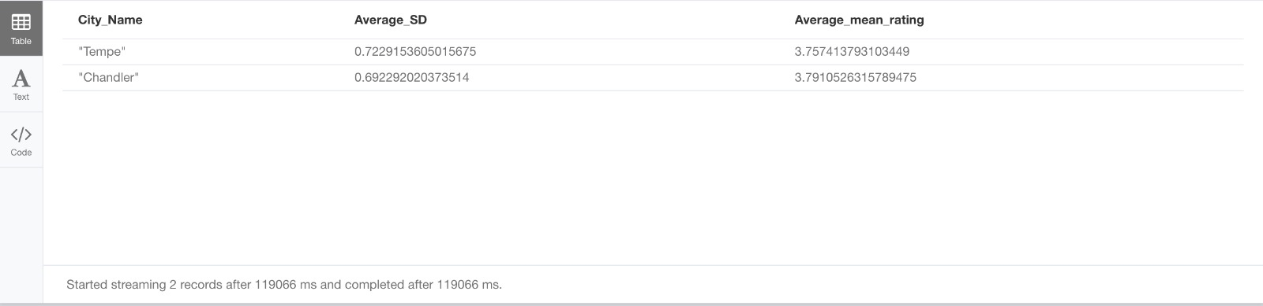

We use these queries to determine if geographical proximity has any bearing on the uniformity in business ratings and divergence. We notice from our results that businesses in Tempe have an average standard deviation of approximately 0.723 while businesses in Chandler have an average standard deviation of approximately 0.692. This deviation is not high considering that the average ratings for both cities is approximately 3.7. Thus, it would be safe to conclude that geographical proximity may have a bearing on the reviews maybe owing to user preferences, user behavior or class of people living in the area.

1. **SAS**

**Identification of fake reviews using SAS**

In this part, we will try and identify fake reviews using SAS. We first exported 10000 reviews into a csv file, from MongoDB and then loaded the same onto SAS. However, we ran into some memory issues, so we used only 1000 reviews for our analysis. Following is the snapshot of the SAS model.

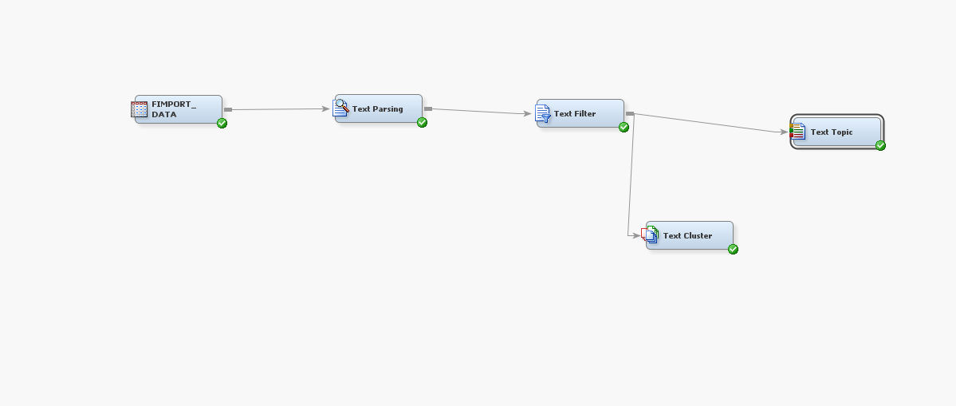

We first imported the data in SAS and created a library and SAS table. The columns exported were review id, review text and rating. We used review text and rating to identify abnormal patterns like too many good adjectives in 5 rated reviews and extreme negative adjectives for 1 and 2 rated reviews. Post data import, we parsed and filtered the data. Following is the output obtained on filtering the data.

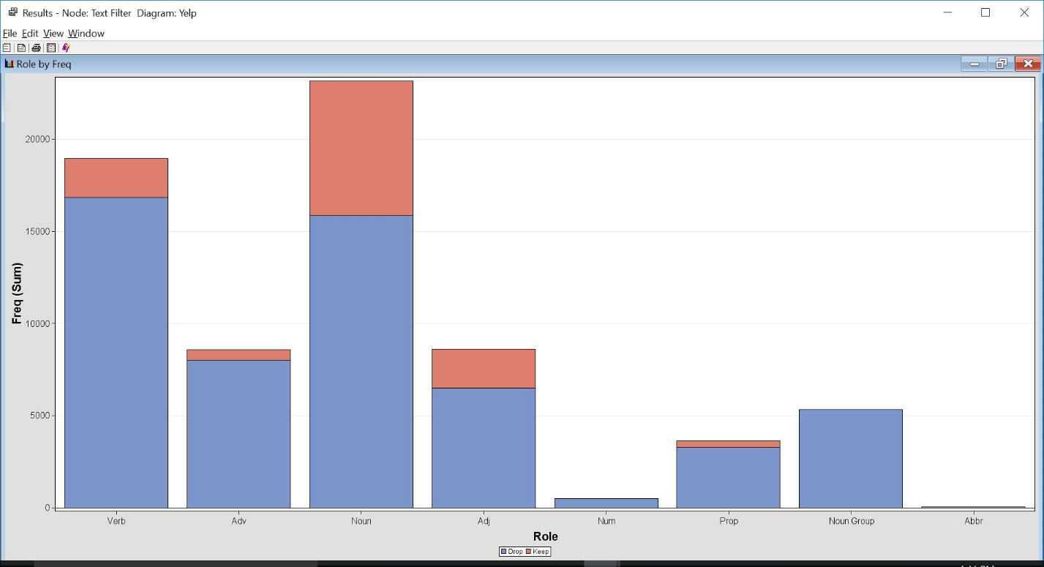

Red indicates words that SAS has marked as relevant and to be used for further analysis. Blue are dropped words. We then performed text clustering, which gave us the following output. Next, we performed text clustering to find out the frequency of adjectives, which might give us some indicator check whether reviews are fake or not. If the occurrence of adjectives like ‘amazing’, ‘great’, etc is very high and rating of the reviews is 5 then they most probably would be fake. This is not a foolproof method to exactly identify fake reviews, but this will definitely help in narrowing down the serach. Unfortunately, from the 1000 reviews selected we did not find such patterns. We would need to perform the same analysis for a larger set of data.

1. **Yelp Mock-Up User Interface**

**Business Page:**

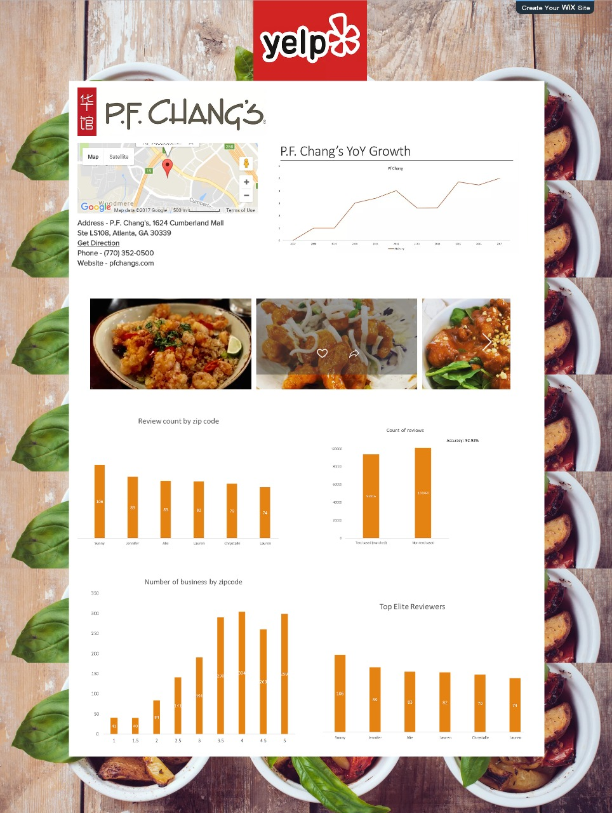

**User Page:**

